Scratch research data:
“Driven by busy lifestyles, consumers are drawn to innovations that improve convenience and quality of life. These consumers desire smart devices that simplify life without adding complexity, making AI-powered companions like Ballie an appealing prospect. However, many consumers are still reluctant to fully embrace this technology due to concerns about their cost. In fact, 44% of US consumers believe these devices are too expensive, making consumers uncertain whether the benefits outweigh the initial investment.” (source 2)

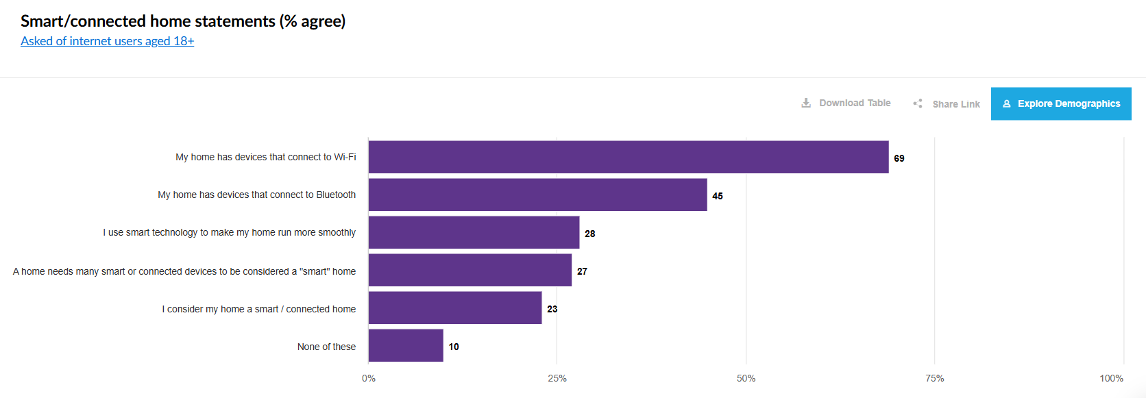
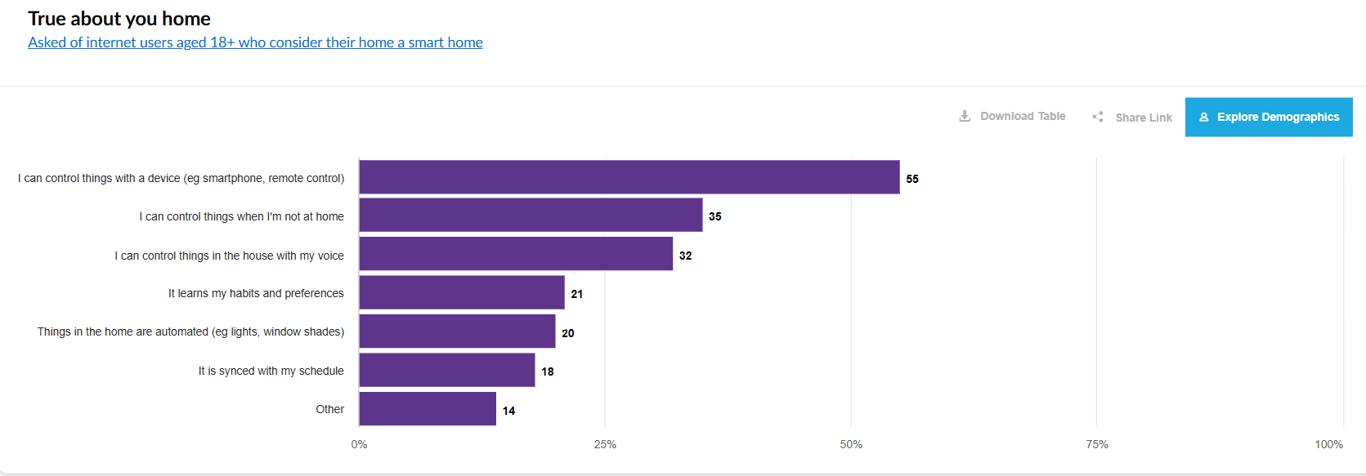

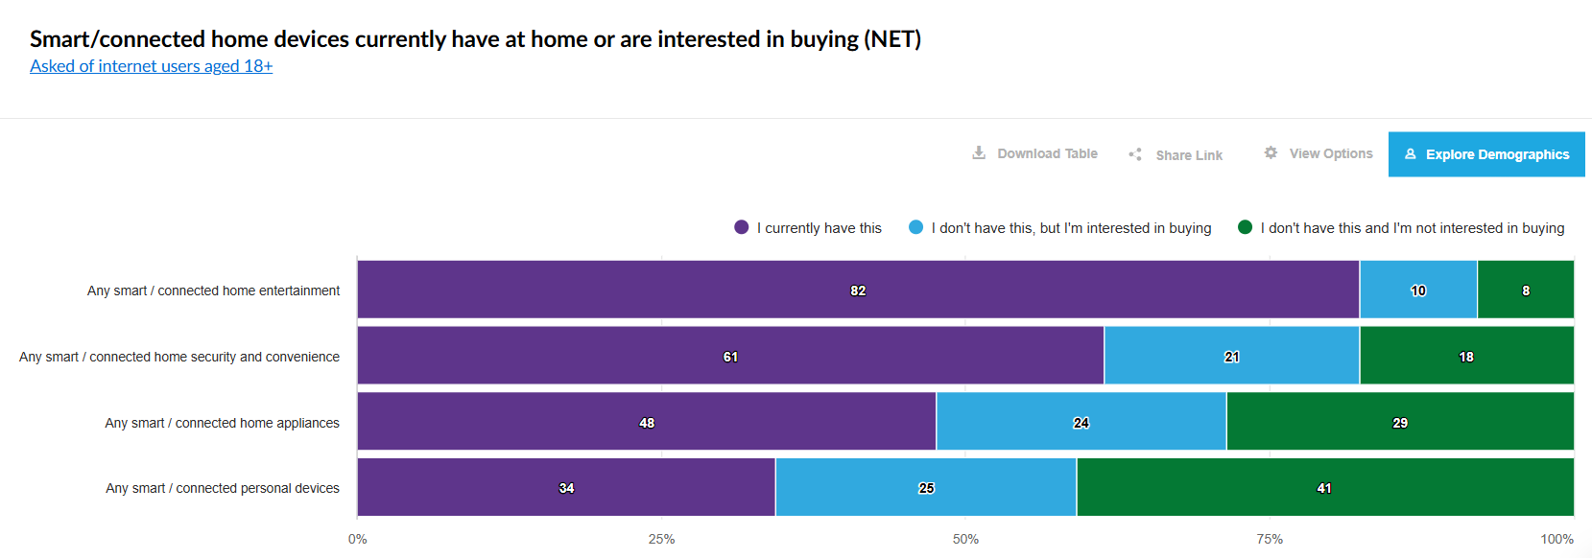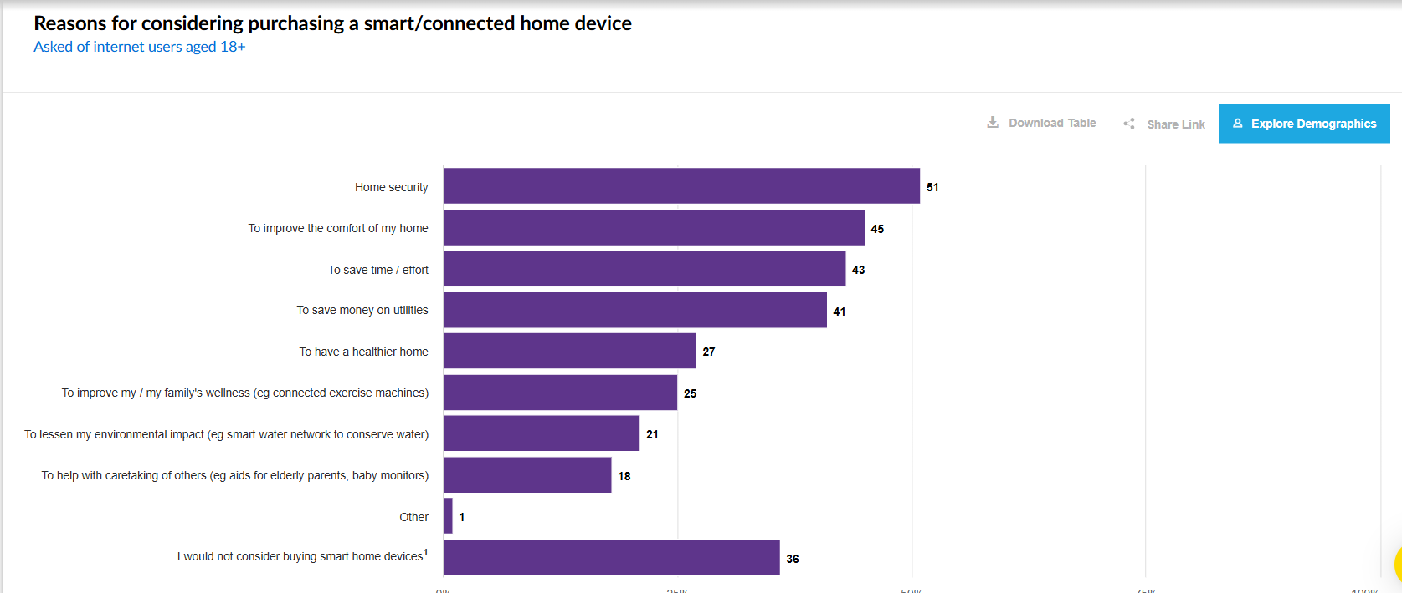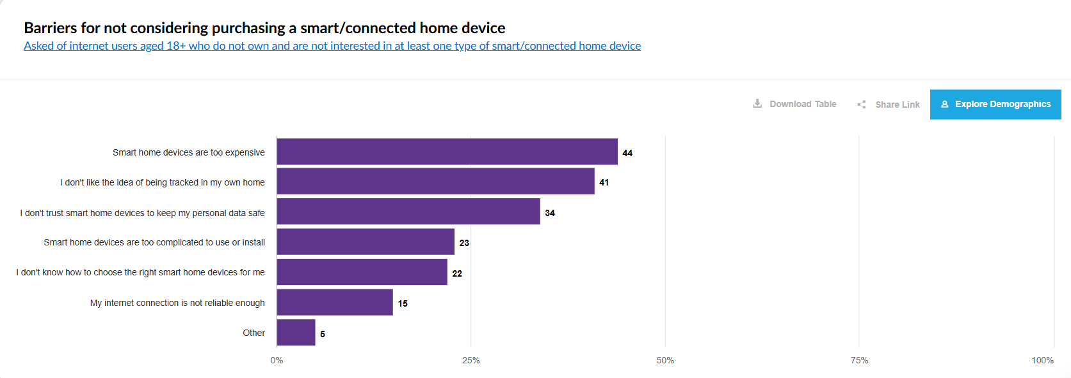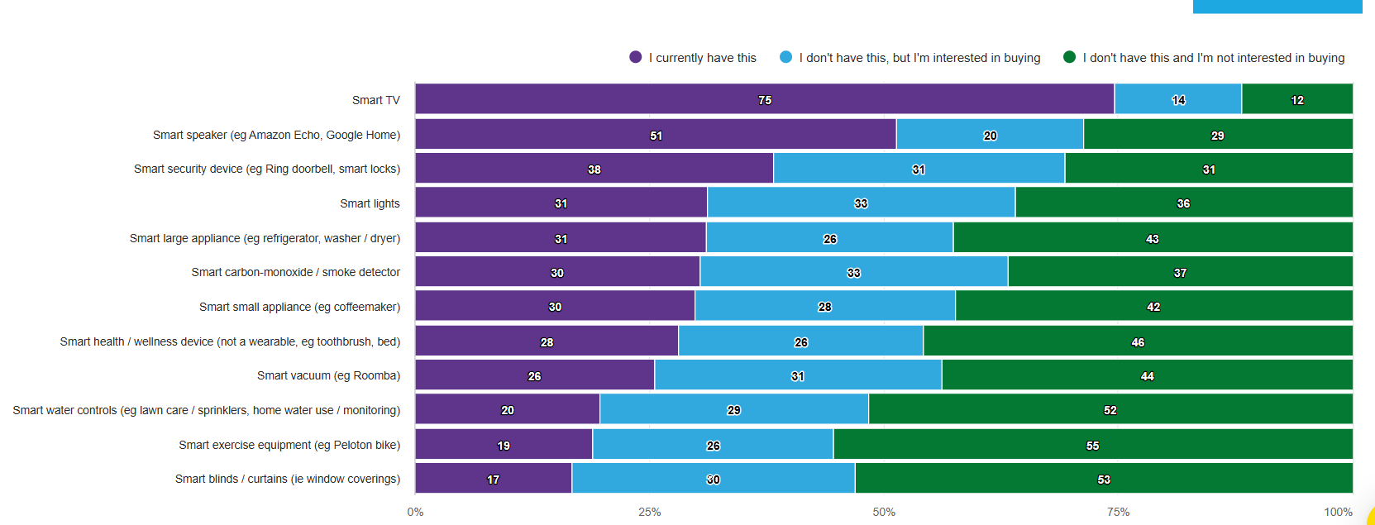
^^source 2 graphs. Figure out how to use and cite
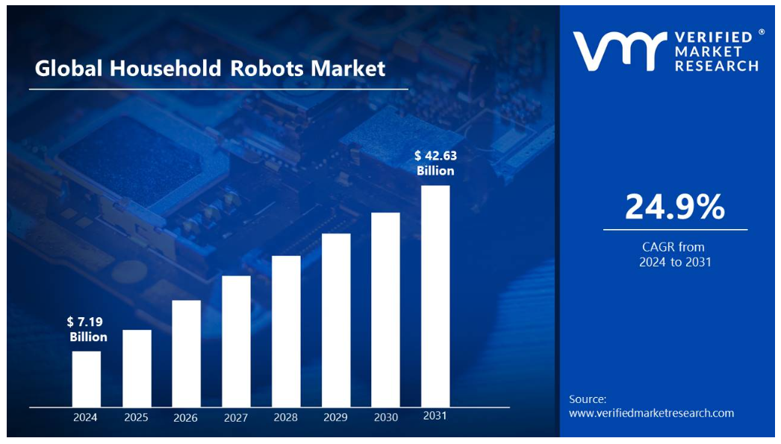
^^source 3 graph

“Limited Functionality and Performance: Limited functionality and performance could limit the growth of the household robots market. Despite progress, many robots still struggle with complex tasks and difficult environments. For instance, vacuum robots frequently struggle to navigate cluttered spaces, clean corners, and handle thick carpets. Mopping robots may also struggle to remove sticky stains efficiently. These constraints make them less useful than standard cleaning procedures.“
(source 3 struggle with cleaning robots)

Possible sources:

Source 1:
https://research.ebsco.com/c/m65exo/viewer/html/7sloa4t5mb
^^ talks about how iRobot is going out of business
^^ FOR RECOMMENDATION REPORT

Source 2:
https://reports-mintel-com.byui.idm.oclc.org/trends/#/observation/1217405?fromSearch=%3Ffilters.category%3D135%26freetext%3Drobotics%26last_filter%3Dcategory%26resultPosition%3D3
^^ home robotics need to be smarter and more capable to make it in the market

Source 3:
https://www.verifiedmarketresearch.com/product/household-robots-market
^^ how the market is going towards AI home robots

